

**A TECHNICAL REPORT ON**

**STUDENT INDUSTRIAL WORK EXPERIENCE SCHEME (SIWES)**

**AT**

KANO STATE WATER BOARD P.R.S

**BY**

**UMAR HARUNA ABDURRAHMAN**

**ND/CET/16/0075**

**AND**

**YAHYA ABUBAKAR SHEHU**

**ND/CET/16/0014**

**SUBMITTED TO:**

**ENG. ABUBAKAR SAMINU**

**COMPUTER ENGINEERING DEPARTMENT**

**SCHOOL OF TECHNOLOGY, KANO STATE POLYTECHNIC**

**IN PARTIAL FULFILMENT FOR THE AWARD OF NATIONAL DIPLOMA IN COMPUTER ENGINEERING**

JUNE, 2018

## DEDICATION

We dedicate this report to Our family and school for their tireless support and compassion towards my humble self during the Industrial Training period, Also dedicate this report to our father and mother whose guidance and support help us come this far, Special thank to all my brother for support and advise.

## ACKNOWLEDGEMENT

Firstly, we would like to thank Almighty Allah for giving Us the opportunity, strength, health and courage to carry out this course successfully. And We would like to thank Our family for their uncountable support and prayers, who always encourage us, May Allah reward them super abundantly.

Also we would express my profound gratitude to all people who contributes tremendously towards my educational career, the people around me, friends and the entire staff of our prestigious Department, Computer engineering technology.

Our special thanks go to employer KANO STATE WATER BOARD, K/NASSARAWA NO.675 who assisted me a lot in conducting Our Industrial Training activities. And also thank my supervisor Mal. Abubakar Saminu who had gone through the script and forwarded the possible errors and corrections to be made; finally I would like to acknowledge my colleagues that we experienced the same training for a wonderful and peaceful staying together without any misunderstand.

## ABSTRACT

This technical report is based on our Industrial experience obtained during our four (4) months student industrial work experience scheme (SIWES), which we undertake at Kano State Water Board P.R.S, This technical report contains all the activities engaged in during our Students Industrial Work Experience Scheme (SIWES) at the organization, we also learnt to been punctual and politeness, honesty and contentment in our period of my attachment.

The most important is that I have learnt the idea of working in office, the character of approaching people in a public and also a good act of receptionist during my attachment period.

## TABLE OF CONTENTS

## 

Contents

DEDICATION 2

ACKNOWLEDGEMENT 3

ABSTRACT 4

TABLE OF CONTENTS 5

CHAPTER ONE 6

HISTORY OF SIWES 6

1. Chapter 4 1.0 INTRODUCTION 6
2. Chapter 5 1.1THE STUDENTS INDUSTRIAL WORK EXPERIENCE SCHEME (SIWES) 6
3. Chapter 6 1.2 AIM AND OBJECTIVES OF SIWES 6
4. Chapter 7 1.3BODIES INVOLVED IN THE MANAGEMENT OF SIWES 7

1.3.0ROLES OF FEDERAL GOVERNMENT 7

1.3.1ROLES OF INDUSTRIAL TRAINING FUND (ITF) 8

1.3.2ROLES OF INSTITUTIONS 8

1.3.3 ROLES PLAYED BY THE EMPLOYER 8

1. Chapter 8 1.4 FUNCTIONS OF LOGBOOK 8
2. Chapter 9 1.5 CONCLUSION 8

CHAPTER TWO 10

HISTORY BACKGROUND OF ORGANIZATION 10

2.0 INTRODUCTION 10

2.1ORGANIZATIONALSTRUCTURE 10

1. Chapter 10 2.1.0 ADMINISTRATION AND FINANCE DIVISION 11
2. Chapter 11 2.1.1PRODUCTION DIVISION 11
3. Chapter 12 2.1.2 GREATER KANO WATER SUPPLY DIVISION 11
4. *Chapter 14* 2.1.3 SEMI-URBAN WATER SUPPLY DIVISION 11
5. Chapter 14 2.1.4 COMMERCIAL DIVISION 11
6. Chapter 15 2.1.5 PLANNING RESEARCH AND STATISTICS DIVISION (P.R.S) 12

CHAPTER THREE 14

The process Component and Description 14

Introduction 14

HOW TO POST CUSTOMER PAYMENT IN PAYMENT SOFTWARE 15

HOW TO USE MS-WORD 17

HOW TO CREATE FORM 17

HOW TO DESIGN WEB SITE USING HTML 18

CONCLUSION 20

SUMMARY 21

RECOMMENDATION 22

CONCLUSION 23

REFERENCES 24

## CHAPTER ONE

## HISTORY OF SIWES

# 1.0 INTRODUCTION

This chapter gives an account of the reasons behind the SIWES, history and its objectives and function of logbook.

The government’s decree No. 47 of 8th Oct; 1971 as modified in 1990,emphasize the capacity that build up human resources in industry, commerce and government through training and retraining of workers in order to effectively provide the much needed high quality goods and services in a dynamic economy. This decree led to the establishment of industrial training fund (ITF) in 1973/1974.

The increase in rate among our industrialists in which the graduates of our institutions of higher learning, lack adequate practical background studies preparatory for employment in industries, point the way to the formation of students Industrial work experience scheme (SIWES) by ITF in 1993/1994 (Ojokuku, 2005). ITF has as one of its key functions; to work as cooperative entity with industry and commerce where students in institutions of higher learning can undertake mid-career work experience attachment in industries which are accordance with student’s area of study.

# 1.1THE STUDENTS INDUSTRIAL WORK EXPERIENCE SCHEME (SIWES)

Is a skilled-Training program designed to expose and prepare students of Agriculture, Engineering, Technology, Environmental Science, Medical Sciences and Pure and Applied sciences for the Industrial work situation which they likely to meet after graduation. Duration of SIWES is four months in Polytechnics at the end of NDI, four months in College of Education at the end of NCE II and six months in the Universities at the end of 300 or 400 or 500 levels depending on the discipline (korisdappa, 2004).

# 1.2 AIM AND OBJECTIVES OF SIWES

1. Provide an avenue for students in institutions of higher learning to acquire industrial skills and experience in their approved course of study.
2. Prepare students for the industrial works situation which they are likely to meet after graduation.
3. Expose students to work methods and techniques in handling equipment and machinery not available in their institutions.
4. Provide students with an opportunity to apply their knowledge in real work situation thereby bridging the gap between theories and practices.
5. Enlist and strengthen employers’ involvement in the entire educational process and prepare students for employment in Industry and Commerce (korisdappa, 2004) Bodies Involved in the Management of SIWES.  
   The bodies involved are: Federal Government, Industrial Training Fund (ITF), Other Supervising Agencies are: National University Commission (NUC), National Board for Technical Education (NBTE)& National Council for Colleges of Education (NCCE).

The functions of these agencies above include among others to:

1. Ensure adequate funding of the scheme.
2. Establish SIWES and accredit SIWES unit in the approved institutions.
3. Formulate policies ad guideline for participating bodies and institutions as well as appointing SIWES coordinator and supporting staff.
4. Supervise students at their places of attachment and sign their log-book and ITF Forms.
5. Set and process student’s log-books and forward same to ITF AreaOffice.
6. Ensure payment of Allowances for the students and supervisors.  
   Therefore the success of the SIWES depends on the efficiency of the ministries, ITF, institutions, employers of labor and the general public involved in articulation and management of the program. Therefore, the evaluation of SIWES in tertiary institutions in meeting up with the needs for the establishment of the program is necessary.

# 1.3BODIES INVOLVED IN THE MANAGEMENT OF SIWES

1. Federal Government
2. Industry
3. Supervisory Agencies (NUC, NBTE)
4. Institution
5. Employer
6. Students

### 1.3.0ROLES OF FEDERAL GOVERNMENT

* To provide enough fund the federal ministry of industries to fund the scheme.
* To make it mandatory for all industries, companies and government sector to give spaces for students under the decree of 1989.
* To increase percentage fund to employ students.

### 1.3.1ROLES OF INDUSTRIAL TRAINING FUND (ITF)

* To formulate guidelines and policies on the scheme.
* To provide students with logistic materials necessary for implementation.
* To organize annual national conference.
* To get the master list of the students, compiled and signed by the SIWES coordinators of each institution.
* To ensure proper payment of students allowances.

### 1.3.2ROLES OF INSTITUTIONS

* To establish SIWES coordinating unit.
* To prepare and submit master list of eligible students that participate in the scheme, to ITF.
* To ensure SIWES orient ation.
* To supervise the students at the area of attachment, and mark their log books.

### 1.3.3 ROLES PLAYED BY THE EMPLOYER

* To accept the students for attachment.
* To allow students to have access to their facilities.
* To train the students techniques in handling tools, equipment and machineries

# 1.4 FUNCTIONS OF LOGBOOK

* It serves as a training manual for supervisors to guide and follow students learning activities.
* It affords the student’s the space for clearly explaining the detail procedure mastered.
* It affords the students an opportunity of noting the connection between experiences learned in the school and at work places.

# 1.5 CONCLUSION

In conclusion, Student Industrial Working Experience Scheme (SIWES) helps student to acquire work experience and become familiar with some software and machines which are not available or are not easily access in the institution. It also bridge the gap between the theory taken during lectures and the practical gained during the 4months working experience. And also students learned how to fill in their logbook on daily basic.

## CHAPTER TWO

## HISTORY BACKGROUND OF ORGANIZATION

## 2.0 INTRODUCTION

Kano state water board, carved out from the old water resources and engineering construction agency (WRECA) in 1991 is 100% government owned water authority .it is changed with the responsibilities’ of abstracting treatment and distribution of potable water of the urban and semi-urban areas of Kano state therefore its inherited from WRECA many water treatment plants monitarized bore-holes schemes and many kilometers of frank and distribution pipelines are all over the Kano state

Initially the activities of the board were being fully financed by the government. But as time went on burden was becoming unbearable and therefore gradual commercialization process was placed in motion. For the government to maintain some degree of social services especially to the rural poor, all the motorized bore-holes based scheme were transferred to the various local government authorities. While the urban and regional water supply scheme were maintained under the water board on condition that it collects enough revenue to operate and maintain them and also to take care of its over head and personal costs. Tremendous achievement is made towards these objectives, because so far the board is being able to pay its salaries, electricity, fuel lubricants equipment repairs and most of the required water treatment chemicals.

## 2.1ORGANIZATIONALSTRUCTURE

Being a Government owned organization, Kano state Water Board is governed by part time Board of directors appointed by the state Government. But for the general administration of the authority a permanent management team headed by a managing Director is in place. Under the managing Director, there is the sectary Legal Adviser public relation officer, Internal Auditor and seven (7) Divisions that are being headed by General Managers Admin and Finance Productions, Greater Kano, Water Supply, Semi Urban Water Supply, technical Services, Engineering and Commercial Division. In order to have better picture of the scope of the Water Board: it will be pertinent to have a brief examination of its various Divisions and their function.

# 2.1.0 ADMINISTRATION AND FINANCE DIVISION

The Division is responsible for the day to day administration and financial control of the water board Headed by a General Manager; it consists of two sections finance and supply, administration and personnel each being overseen by an Assistant General Manager.

While the finance and supply section controls all the Board income expenditures and assets, the administration and personal section are responsible for internal and external communication staffing of the various Division staff, development: discipline and advancement, provision of office or residential accommodation and transportation.

# 2.1.1PRODUCTION DIVISION

This division may be seen as the nerve centre of Kano state water board. This is because more than 90% of the potable water supplied to the Kano metropolitan is being produced by this division. The total quantity of water being treated by this division, as at the time of this research, is about 300 million litres a day, coming from three (3) conventional plants which are located at Panshekara village, near Challawa River.

1st water work of 20 million litres (1932)

2nd water work of 90 million litre (1974)

3rd water work of 110 million litres (1992)

# 2.1.2 GREATER KANO WATER SUPPLY DIVISION

Greater Kano is an area having 30km radius from the centre of the ancient city of Kano. It is responsibility of this division to distribute the treated water coming from the Challawa and Tamburawa water works to the Greater Kano.

# 2.1.3 SEMI-URBAN WATER SUPPLY DIVISION

The semi-urban water supply is created to take care of the provision of portable water to all the other urban and semi-urban towns throughout Kano state outside the 30km radius of Kano city under this section there are thirteen (14) regional scheme out of which (10) ten are utilizing impounded water from dams, while the remaining three (3) are using tube wells sunk in river beds.

The combined production capacity of these regional water treatment plants is at present estimated to be about 110 million litres a day serving over 100 loans in six zones.

# 2.1.4 COMMERCIAL DIVISION

Commercial Division is primarily responsible for the billing and collection of water revenue from our customer. Its activity covers both the Greater Kano and the semi-urban areas. In addition to the water revenue collection, it is also responsible for our other commercial ventures that include bore-hole, drilling, printing etc.

# 2.1.5 PLANNING RESEARCH AND STATISTICS DIVISION (P.R.S)

It was handing over or taken out from commercial division, the P.R.S Department is exists in conformity with the civil service reforms of 1988 which prescribed the creation of this department in every ministry and extra-ministerial department.

The Kano state water board PRS division was curved out from the existing of engineering and commercial division and Greater Kano water production I n the year of 2011.

MANDATES OF THE PLANNING RESEARCH AND STATISTICS DIVISION

* Gathering data from all the division of the board with a view to transform the data for use in policy formulation.
* Monitoring and evaluation of programs, projects and their implementation.
* Co-ordination preparation of the board’s capital Budget and rolling plans for progressive and sustainable development of the board.
* To formulate strategic and perspective boards plans of action.
* Coordinate linkages with the international Development partners on program and projects.
* Providing ICT support to the board, including the production of computer bills for the commercial division.
* Manage the Board library/archive as repository and documentation center.

**2.1.6 CONCLUSION**

In conclusion, I was able to know the history of Kano state water board. A water revenue activity has been Carry out in Nigeria since 1932

## 

## CHAPTER THREE

## The process Component and Description

## Introduction

This chapter contains the components, processes and projects carried out during our attachment .I will now mention the techniques/skills that I have learnt in the presence of the attachment particularly based on my course of study which are enumerated below:

* How to Post Customer Payment Bill.
* How to use ms-word.
* How to create forms.
* How to draw revenue detail.
* How to design web site. Using HTML.
* How to record monthly consumptions of Kedco/Diesel by centre.
* How to make computer’s connection.
* How to create fills forms for centre’s revenue.
* How to use electrical blower.
* How to make different bills and printed them.
* How to make flat rate bills and printed.
* How to calculate meter particulars manually.
* How to record total chlorine consumes monthly

1.1 Working Experience

**Introduce**

In this chapter were going to discuss the contract whose listed at above

## HOW TO POST CUSTOMER PAYMENT IN PAYMENT SOFTWARE

How to post costumer payment using payment software which we store all the customers’ details e.g. Water consumes by a costumer and current charges, arrears and fixed/connection charges etc, than printed out the bills.

Firstly

* Click on the payment software icon to open.
* Log in the use and password.
* Click on payment or naira icon.
* Select type of payment you will make payment with: Metered Account or Flat-rate Account (un-meter).
* For flat-rate account click on un-meter account and type the contract ID number or Account name (frequently use contract ID).
* Enter the date of posting and billing office.
* Enter the amount and mode of payment (cheque no/cash).
* Enter the receipt number and date.
* Enter the date of payment.
* Click on save icon then start another.
* 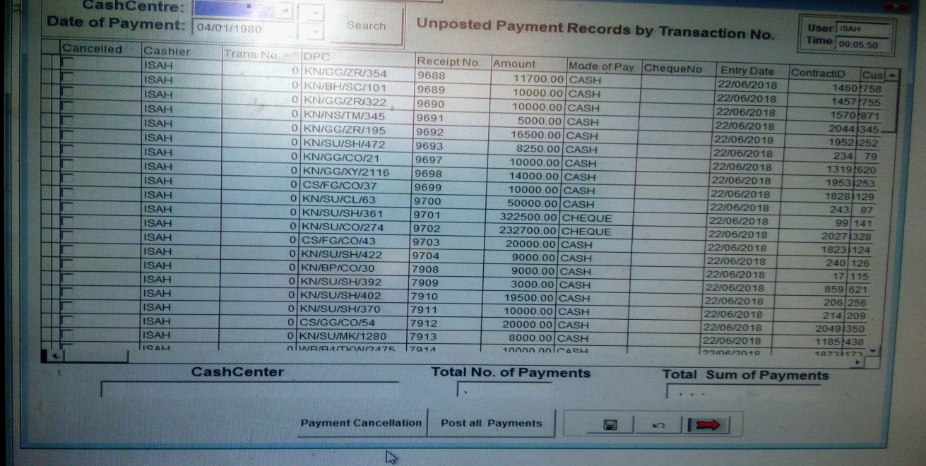
* For meters account click on meter icon or meter name.
* Use fonter foil which collect from the commercial division to fill.
* Date of posting and name of the person whose post.
* Enter date of payment and billing office.
* Enter meter reading date and for reading date.
* Enter the meter number or name.
* Enter the present reading to get the consumption and naira value.

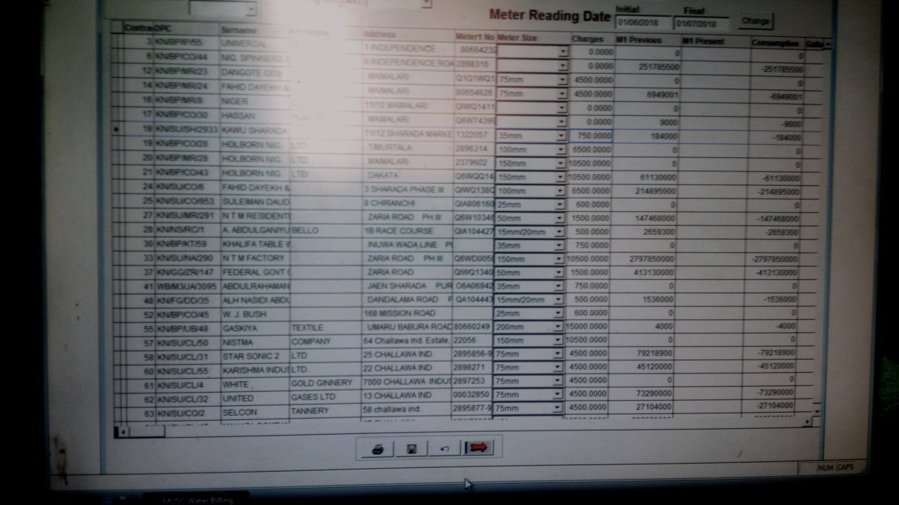

* Save and go to another account

## 

## HOW TO USE MS-WORD

1. Ms-word:-Is one of the computer program designs purposely to create, edit, and produce text documents, then it’s called word processing in computer terminology.

Ms-word provides a compatibility feature through which you can still read and write documents created using previous version of the word, and can also create new document in the old format.

**HOW TO START MS- WORD**

* Click the start button present in the taskbar
* A start menu appears, move the mouse pointer on all programs option, a sub-menu also appears
* Inside the second menu, place the mouse pointer over Microsoft office option, immediately a new sub-menu appears that content the office component
* Place the mouse pointer over Microsoft word and click on it, immediately the ms-word environment appears on your screen, as shown below



MS-WORD ENVIRONMENT

## 

## HOW TO CREATE FORM

We are writing forms and bills using ms-word environment than print them out to the hardcopy.

To make record form:

* Open the ms-word software.
* Write the header of the form.
* Draw the table row and columns.
* Insert the contact in them and save.
* 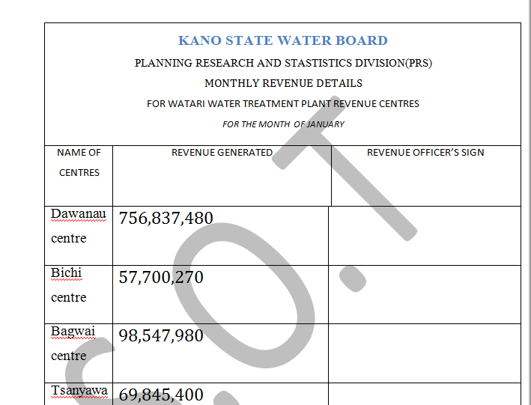

## HOW TO DESIGN WEB SITE USING HTML

1. Click on notepad icon on the desktop to open the software.
2. Type your code and save with the extension of html.
3. Open the shortcut file it will open in the browser.

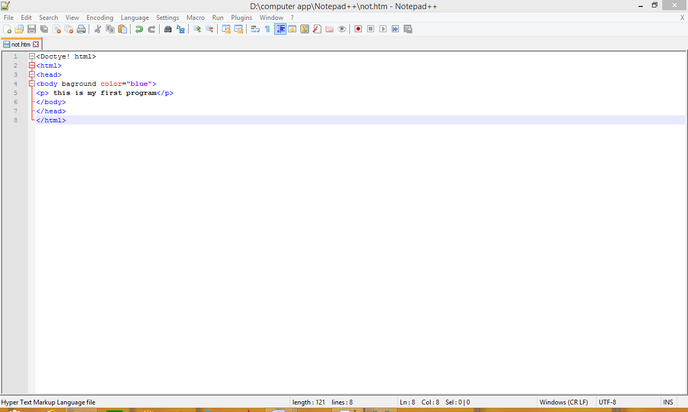

1. Than execute the program.

HOW TO RECORD MONTHLY CONSUMPTIONS OF KEDCO/DIESEL BY CENTRE

* Collect the fonter foil for the commercial division.
* Open the software and type up the information on the fonter foil.
* Save and printed them out.
* Summit to head officer’s and sign.
* Close the software.

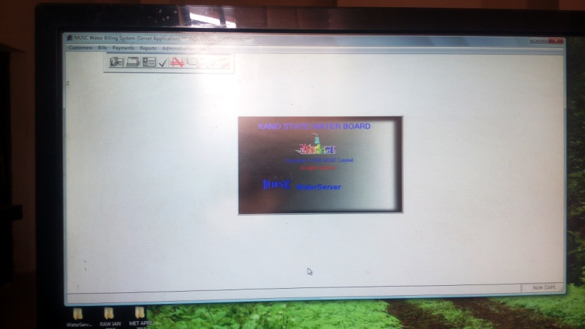

HOW TO CREATE FILLS FORMS FOR CENTRE’S REVENUE

* Open the ms-word and click on insert.
* Insert the table and specify the row and columns.
* Insert the content inside the table.
* Save and print them out.

HOW TO USE ELECTRICAL BLOWER

* + Connect the blower in the power or electrical applies.
  + Open the device you intend to use.
  + On the blower than floor out the dust in it.
  + Turn it off and plug out from the power.

HOW TO MAKE DIFFERENT BILLS AND PRINTED THEM

* Commercial divisions are responsible for making bills.
* Type it in ms-word and insert the details
* Save and printed out

HOW TO CALCULATE METER PARTICULARS MANUALLY

* Enter the previous and present reading.
* Subtract the previous by present to get the consumption
* If the value is more than million.
* Take the first million and divide by 1000*150
* Remaining divide by1000*200
* Then add them together
* To get the naira value
* If it less than million than go through and divide the consumption by 1000*150 to get the naira value.

## CONCLUSION

In Conclusion, at our 4months SIWES we experienced some challenges and problems where by my industrial based supervisor enlighten us on how to solve the problems related to electoral activities.

|  |
| --- |
| SUMMARY This technical report has been written for the evidence concerning the knowledge acquired during the attachment and the aims and objectives of this report is for the student to get a practical aspect and experience to explain pointing out the ideas gained and provide them to his institute supervisors in order to confirm that he has really got the experience not only written a report on them and after the supervisor has confirmed his deeds and test the student for the knowledge acquired will also improve the capability of the student to read hard and his fore coming students to take it serious and important on their attachment this all about the technical report after carrying some practical for Student Industrial Work Experience Scheme (SIWES) during his Industrial Training Fund I T F. RECOMMENDATION All the components that we used during our practical are clearly observed it became simple for us because all our trainers tried their effort to simplify the experiment to make it easier for us to understand and practice it in a workshop and in a personal position we find ourselves, the component given to us are of different types like a Cisco it is of different types and the version which is mostly up-graded and renewed but our practical teachers were expanded their thinking and explained to us clearly for the level of our understanding one of them said “The installation of a Cisco software setup is the same but there is some changes due to the modernization of the software” and have seen by downloading and see the version of this software. Most of them were advising us to start our practical from the beginning which from the smaller to the bigger one they also said every student who wanted become special in every aspect of his study must keep practice on each and any assignment or work given to him either in a school or everywhere find himself which most of them appreciate our effort and be surprised of the type of the lectures acquired in the school. CONCLUSION Finally, we have successfully done our Student Industrial Work Experience Scheme (SIWES) in happiness by understanding the quality and essence of acquiring Industrial Training a Fund which we have some experience learnt by putting more effort and showing our respect to them in each kind of work they demanded us to do which will express the acceptance of our work and the main reference for us in possessing the certificate of National Diploma in Kano State Polytechnic for improvement. REFERENCES |